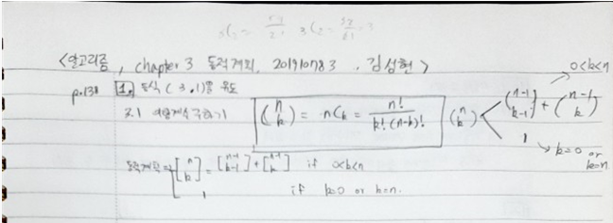

4.

int bin2(int n, int k) {

index i, j;

int B[0..k];

for (i = 0; i <= n; i++)

for (j = 0; j <= minimum(i, k); j++)

if (j == 0 || j == i)

B[i] = 1;

else B[i] = B[i - 1] + B[j];

return B[n];

}

